
From your chairman
I do hope that you all had an enjoyable Christmas and a happy New Year.
As a club we had a very good year with all of our teams doing really well, and individuals also.
At the end of the year we had the honour of being chosen as the NAF Riding Club of the month. Gemma Read very kindly nominated us for this award, and we duly won it! Our thanks go to Gemma for the lovely comments she made about our club. They gave us a full page write up in the December issue of the Ridgeway Rider, of which I have a copy if anybody would like to read it.
Thanks must go to all of the members who stepped forward and helped us at our events this year. We could not do it without your help so thank you very much.
We have a very full calendar for the coming year and I do hope that we have catered for all of you, but as always if there is anything that you would like us to put on for you, please speak to a member of the committee and we will try to oblige.
I would like to wish you all great success in anything that you wish to achieve in the coming year with the Club, and to thank you all for your continued support.
Daphne Smith
…newsletter
In this issue >>>

Jan 2012

- Teams report
- Dressage results
- Diary
- TREC
- Helpers
Coming soon

- KLRC Treasure Hunt

- Tack Sale

B&W Equine Vets Visit.

- KLRC Winter Dressage Series continues

- KLRC Host Area 9 Combined Training Qualifier

- All the usual rallies and training sessions

See www.klrc.co.uk for a full diary of forthcoming events.

All KLRC schedules are available on the website.

An Evening At Whatley Manor….

Back by popular demand we are holding another afternoon and evening social event at Whatley Manor on Tuesday 10th July 2012.
The afternoon will start with a tour of the gardens followed by a private screening of the film “War Horse”. This is followed in the evening by a delicious three course dinner served in Le Mazot Brasserie. All this for the bargain price of £37 per person.
Details of how to book will be available on the website nearer the time and in the next newsletter however to reserve your place please contact Daphne Smith.
Teams
KLRC team successes go from strength to strength with our Novice Indoor Show Jumping Team winning the Area 9 qualifier at west wilts on Sunday 13th November. The team of Elaine Chamberlain, Lizzie Donaldson, Steph Hunter and Chris Ticehurst finished on a score of 4 faults after the 2 rounds so we were through to the jump off against Bath RC and SVRC. Thanks to some nifty turns and clean jumping we ended with 4 faults along with Bath RC but the KLRC girls were the quickest!! The team go on compete at the British Riding Club Winter Championships at Hartpury in April 2012. Our
Junior Indoor Show Jumping Team of Abbey Read, Gemma Read, Hannah Boughton and Alice McGory also did extremely well in coming 2nd so well done to all.
The next team competition is the Winter Dressage for seniors and juniors. This consists of two team member riding a prelim test and two riding a novice test. The Area 9 qualifier is being held at Leyland court on 12th Feb 2012. If you are interested in competing for the club please talk to Hayley Godwin for seniors, or Margaret Read for juniors. KLRC has had previous successes in this competition having won in 2009 and coming 5th in 2011 so good luck to all those wanting to take part.
We have all the dates for the Area 9 qualifiers for 2012 detailed in this newsletter. KLRC is running the new Combined Training Team Qualifier for the Festival of the Horse Championships. This is on the 22nd April at Leyland Court. As well as team members we will be needing helpers so if you would like to volunteer to help on the day please contact Nickie Coombs on robandnickie@btinternet.com or 07796 990204.
Important Information to all Riding Club Members:
BRC rule change. All members wishing to compete at BRC Area Qualifiers and BRC Championships now need to have their hat tagged to ensure they are of an acceptable standard. The hat needs to be checked and tagged by the Area 9 qualified person before any member is allowed to compete. This is currently Gill Penberth. Only Hats to one of the following specifications are acceptable:

Either PAS 015 (1998 or 2011) or BSEN 1384 (1997) or EN 1384 (1996) AND MUST HAVE BSI Kitemark | ASTM F1163 (2004) AND MUST HAVE SEI mark | SNELL E2001 AND MUST HAVE Official SNELL label and number | AS/NZS 3838 (2003 or 2006) AND MUST HAVE SAI Global mark
At all BRC Area Qualifiers and Championships, hats must show a visible BRC ‘hat tag’. Any other standards / dates are NOT acceptable and will not be tagged. Please contact Nickie Coombs or your team manager to get your hat tagged in advance of area competitions to avoid any delays and the risk of elimination.

We would also like to remind all members that when participating in any KLRC run event or rally that hats in compliance with BRC rules must always be worn whilst mounted. For Any Cross Country event or training Body Protectors and medical arm bands must be worn. If you are attending an event or rally on your own please ensure you give the organiser or instructor an emergency contact number.

My First Team Experience…
My name is Alice McGrory (14) and I first joined KLRC in 2011. When I competed in my first junior team event for the club (which was coincidently mine and my horse Connor’s ever competition as a partnership!) it was the Area 9 Novice Indoor Show Jumping Qualifier and our team came second.
I was amazed at the relaxed and organised feel of the event and was made to feel unbelievably welcomed to the club. Our team walked the course together and everyone helped each other in the warm up, I felt supported by the team and the Manager.
Unfortunately I have not got Connor any more however I look forward to going to many more rallies, events and socialising with the rest of the club with the different horses I now ride.
I regularly check the Facebook page for events coming up and try to help out people who place adverts on the page. I think that the main thing that can be taken from my experience is that the KLRC is the single most welcoming club I have ever had the pleasure to be part of.
Alice McGrory

Area 9 2012 Qualifier Dates
For more details please contact one of the KLRC team Managers - Seniors Nickie Coombs and Hayley Godwin or for Juniors Margaret Read.
12/02 - Royal Windsor Dressage (Prelim) & Winter Team Dressage (Prelim and Novice) Qualifier - Leyland Court
18/02 - Royal Windsor SJ qualifier - Stonar
22/04 - Festival of the Horse Combined Training qualifier - Leyland Court
24/06 - Individual and Team Novice Dressage (Prelim) - Longley
08/07 - Horse Trials (Novice 90cm, Intermediate 1.0m, Open 1.1m)- Stonar
16/07 - Team and Individual Show Jumping (Novice 85cm, Intermediate 95cm, Open 1.1m) - West Littleton
22/07 - Individual and Team Open Dressage (Novice and Elementary) and Individual Medium tests - Rabson Manor
TBC - Dressage to Music

Livery available in small private yard in Tetbury. Large stables, sand/rubber arena, good hacking and year round turn out. For more details contact Chris Ticehurst on 07738 597436/01666 505885
Dressage
Well we are halfway through our winter dressage series at Elmleaze and so far the entries have been down on previous years. This is a pity as we try to cater for all, and invite the best judges suitable for the different levels.
The new surface in Elmleaze Stud’s indoor school is very good to ride on, I know that there was a problem when it was overwatered, but this has now been resolved and riders are finding it extremely good. The atmosphere is always good here, very friendly and good fun, so I hope to see more of you at the next competitions. The remaining competition dates are Sunday 19th Feb Tuesday 13th March with the championships on Sunday 15th April.
We have had some different members coming in to help at these events which is very good, as it means that the same members aren’t being asked all of the time. If you would like to volunteer please contact Jenny Lomas or Daphne Smith.
If any of you would like to put your names down for dressage teams please put your name forward to Hayley Godwin for the senior teams, and Margaret Read for the junior teams.
We have the Area 9 Qualifier at Leyland Court on February 12th, so if you feel that you would like to represent your Club don’t be shy, just put your name forward and come to team training at Badminton.
I do hope that you all enjoy your dressage in 2012 and do come along and take advantage of the expert tuition which we offer at our various rallies.
Daphne Smith
KLRC Vet Visit - B&W Equine Group, Breadstone Clinic
16th February 2012, 7pm
We have been invited to have a conducted tour around the brand new facilities at the Breadstone Clinic (near Berkeley) by the Bushey and Willesley Equine Vets.
Its a great opportunity to see their state of the art equipment and find about new advances in equine veterinary medicine.
There is no cost but members need to provide their own transport.
The vets would like to know approximate numbers so please let Jenny Lomas know on 07748716148 or email at jenny_lomas@yahoo.com if you are coming.

KLRC Winter Dressage Series Results
23rd October 2011

Class 1
1st Iain Flower Guiness
2nd Gemma Read Blackmoor Clover
3rd Millie Taylor Silver Dollar
Class 2
1st Nuala Dunne Anastasia
2nd Gabriella Rose Aldata Babe
3rd Alex Harvey Baygo
Class 3
1st Gabriella Rose Aldata Babe
2nd Nuala Dunne Anastasia
3rd Tina Jackson Coraclare Poppy
Class 4
1st Gemma Read Orions Gold
2nd Tina Jackson Coraclare Poppy
3rd Lyn Davidson Doogie

15th November 2011

Class 1
1st Karen Joynson Elite Equity
2nd Steph Hunter Salsa
3rd Emma Lovell Peaches
Class 2
1st Erin Nannes Tidesbrook Red Arrow
2nd Natasha Pimlott Deacon
3rd Karen Joynson Jim
Class 3
1st Erin Nannes Tidesbrook Red Arrow
2nd Natasha Pimlott Deacon
3rd Karen Joynson Jim
Class 4
1st Kathleen Griffiths Howen Clanger
2nd Steph Hunter Skuzz
3rd Tina Jackson Coraclare Poppy

11th December 2011

Class 1
1st Iain Flower Guiness
2nd = D. Pratt Dougal
2nd = Jack Joynson Pinto
Class 2
1st Holly Bevan Pennye Faw Storm
2nd = Iain Flower Guiness
2nd= Jo Knapman Danescourt
Class 3
1st Claire Jackson Morse
2nd Ellie Berry Comet
3rd Poppy Clark Henry
Class 4
1st Claire Jackson Morse
2nd Lizzie Donaldson Mulberry

BE Grassroots Championships 2012 - Badminton

Kings Leaze Riding Club has the honour again of providing the mounted stewards for the cross country day of the 2012 Mitsubishi Motors Badminton Grassroots Championships on Thursday 3rd May. This requires a sane, sensible but fit horse as we are required for the duration of the cross country event, normally about 6 hours with a break for lunch. If you would like to represent the club please contact Nickie Coombs robandnickie@btinternet.com with details of experience plus confirmation that you are available the evening of 2nd May and all day 3rd May. In the event we have too many suitable volunteers we will draw names out of a hat.

Helping at KLRC Winter Dressage Series

Since I joined KLRC last year, both myself and my daughter have experienced some great rallies and a superb camp at Easter, all expertly organised by a handful of cheerful and enthusiastic members. I have looked forward and enjoyed reading each newsletter too.
But who are these people and where do they get the time to organize these things? I’m sure we all recognise the same names that keep appearing. So I suppose I wasn’t surprised when I got a phone call asking me to help with something, in my case, the Winter Dressage Series. My initial thoughts were……Yes, I’m free on those days….What an honour to be asked……But then, suppose something crops up and I need to juggle the kids…….And then, will I be judging? Scoring? But I have only ever done a basic dressage test, Help!!! Anyway no going back I’d said Yes, and it couldn’t be that difficult, could it?
Well the day arrived, the venue had been changed at the last minute due to flooding of the original venue to the Badminton Indoor Arena, thankfully closer to my house. I arrived in good time to a very calm scene and Daphne introduced me straight away to Sandra Hayward who I would be shadowing. To my great relief, Sandra was very approachable and explained my straight forward tasks – letting at most 2 entrants warm up inside the arena before their test, poop scoop when necessary, collect the score sheets after each test, take them back to be marked and double check the . marks, and then transfer the results up on the main score board, and finally to help to sort out the rosettes. I did not need my calculator since she showed me a reliable mental maths method – easy when you know how! When I did relax, I managed a quick chat with a few entrants that I recognised and got to see a few dressage tests through. Some entrants had a few tricky moments, and it made me realize that all horses have their different quirks, and how impossible it is to find the perfect horse!!
By the end, I definitely couldn’t understand why I had been so nervous! A very enjoyable 4 hours (and I was given a very tasty roasted pork bap too!!!).
Jennie Carter
Help Required
If you would like to help at any of our events please contact any of the committee. We are also looking for the following specific support:
Website Updating – We are in need of support in keeping the website up to date. If you feel you could support the club in this please contact Clare Holt.
Newsletter Editing – If you would to help with the editing of the club newsletter please contact Jenny Cole.
Combined Training Area Qualifier – If you would like to help with this Area Competition please contact Nickie Coombs
KLRC Winter Dressage Competitions – If you would like to help with Scoring, Writing or stewarding please contact Jenny Lomas.

I own a 14.2 Haflinger and for a while I had been wanting to try out other equestrian sports other than the box-standard crosscountry, dressage and show jumping. In one of the previous issues of the KLRC’s newsletters, I came across something called TREC. It involves negotiating natural obstacles using basic flatwork and jumping skills, control of paces which consisted of cantering as slowly as you can and then walking as fast as you can for around 150 metres each and trail riding (orienteering on horseback). To me, this sounded perfect as my horse is not great at jumping and is naturally built to go on long hacks, which is similar to the trail rides. In November 2011, KLRC had organised a TREC talk session and a rally – the TREC talk was very well-thought out and they explained everything we would need to know in order to participate in the competition- the rules, the equipment and above all, what each part of the competition consisted of. Control of paces and some obstacles were demonstrated to give us a feel of what we would be facing in the rally the following week; overall, a very informative and revealing session.
However, the part I enjoyed the most was the rally. Here, the theory which we had learnt at the talk was applied in a practical situation except of course, the trail ride which would have been difficult to arrange for a relatively small group of riders. During the rally, we dealt with numerous obstacles including rein back between poles lying on the ground, mounting off a block, an S-Bend, cantering through poles (roughly 70cm apart!), walking over tarpaulin to imitate water, leaving the horse unattended in a circle that it could not leave for 10 seconds and slalom poles (my favourite obstacle) as well as control of paces. After practicing each obstacle individually we decided to take part in a mini competition within our group; your technique and fluency negotiating an obstacle were areas that you were marked on and the timing was the area where points were given for control of paces – cantering being the longest time possible, for optimum points and walking being the quickest time. I was very pleased with my score, having done better in some of the obstacles than when I had practiced and once it was over I wanted to have another go!
I learnt a lot from this amazing experience – not only that I was able to leave my horse for 10 seconds without him galloping off but to my surprise standing stock-still and being very docile, but most importantly, that TREC is a new sport that I am glad to have stumbled across and given the opportunity to participate in and learn about; I am definitely going to give it another go and hopefully, try my luck in a small competition!
Alexa Carter
TREC Lecture Demo and Rally
In November last year the club ran a successful introduction to Trec through a lecture Demo at Elmleaze Stud and a Rally at new House Farm. The following are the experiences from 2 of our members who attended the events. We are planning on holding more Trec events in the future including the rallies detailed in the diary section of this newsletter.

TREC Lecture Demo and Rally Cont….
I had already attempted a few Trec competitions after reading a magazine article and thinking it sounded fun. When the riding club advertised a Trec demo and training session I knew I wanted to do more so booked Chance and myself in. I didn’t know what to expect but as I arrived and unloaded it was clear it was going to be fun. There were 3 of us in my group Celia on Harvey, Steve on Drum and myself and Chance. After warming up our 1st task was the COP or Control of Paces where the aim is to walk as quickly and then canter as slowly as we could between 2 set markers without breaking pace which would lose you all the points. We each had a turn and when it was my go I had to concentrate really hard as Chance has a habit of breaking into trot while in a school but we made it the whole way round in canter, a little too fast but definitely gave us something to work on.
We then moved onto the obstacles. The Bending poles, the faster you go through without touching the poles and staying within the corridor limits the more points are awarded. After a 1st attempt in canter, I think we will stick to trot for the meantime! Steve on Drum did an amazing job of going through in canter.
The corridor, again the faster pace you go the more points awarded. The corridor is very narrow set at 50cm wide but we started out with the poles wider and practised going through in trot then in canter and then gradually the poles were brought together until they were at their official width and we all successfully cantered through. We also used the corridor for our rein back obstacle although the poles are set far wider apart. Rein back though is not one of our strong points but we had a go and it wasn’t a complete disaster but we were given some guidance on how to improve.
Next the S bend, this obstacle which you attempt in walk and negotiate the horse around some very tight turns without stepping out or hitting the poles. We were definitely more successful coming in from the ‘other end’! We did mounting and immobility, Chance was a complete star and remained perfectly still until asked to move which gained us maximum points. Finally we did the ‘bridge crossing’. We had to improvise with some tarpaulin. Chance certainly looked wary about it so I got off to lead him over it the 1st time, then I hopped back on and we crossed it with no troubles at all. We then had a little competition and did all of the obstacles together finishing with another COP. Our walk score was better but our canter was better.
It was fantastic fun and I would recommend it to anyone who just wants to try something different, it suits everyone from happy hackers to those who event so just give it a try!!
Emily Small

Have you found us on Facebook yet…. For up to date information on events, rally spaces etc… please join our group. For more details please contact Sina Hill-Palmer or Wendy Dawson.

Alexa and Troy at the TREC rally
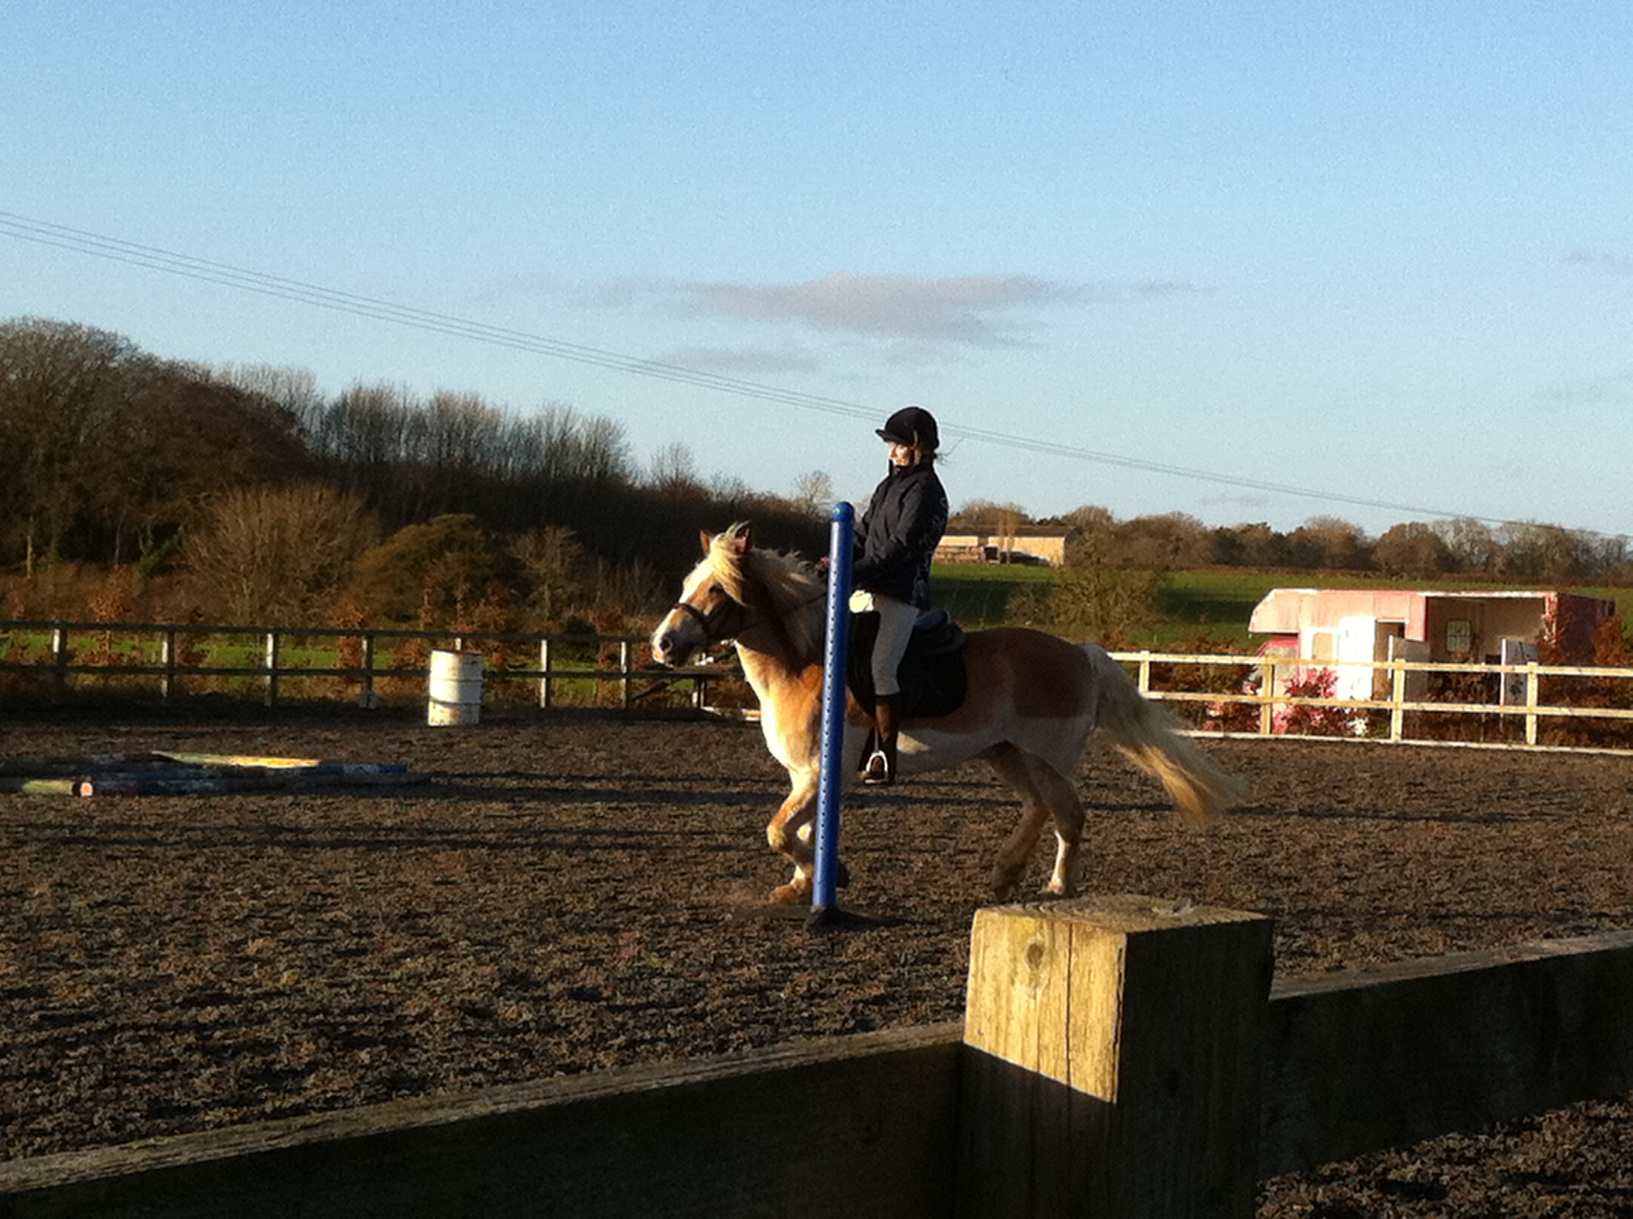

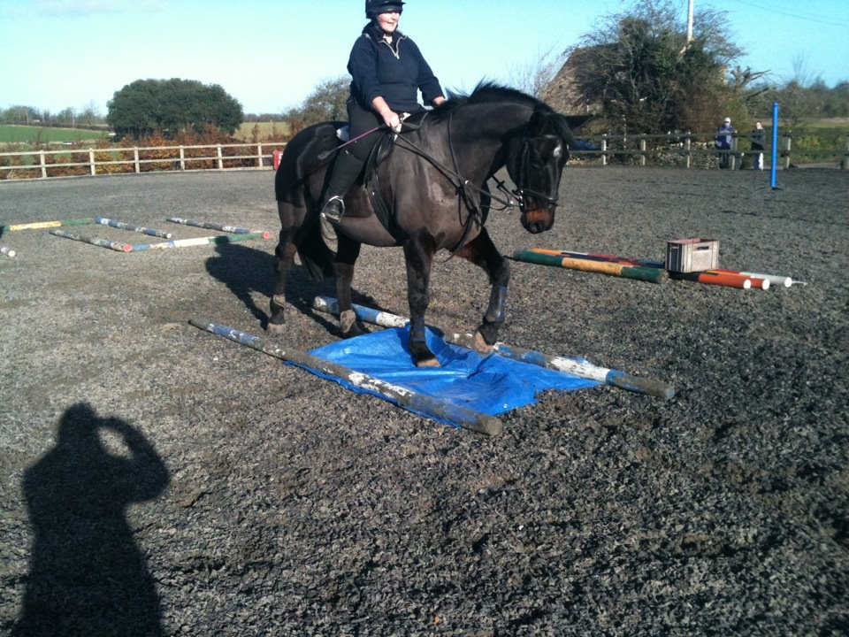

Emily and Chance at the TREC rally
Olympia Horse Show 2012

It is three years since our last visit to Olympia and we thought it was time for another trip. Although it is nearly a year away, we’d like you to all think about joining us.
Tickets will be approx £45.00 and the coach approx £20.00 (This is less than most premiership football matches!). It’s a wonderful day out but we can only run this trip if we have sufficient people and a deposit of £10.00 per person will be required. It is open to members, their families and friends. We hope to book for the Sunday afternoon performance which will be the World Cup Qualifier.
Please think about this now and we will send you a reminder at Easter with more details. We will need the deposits by the end of June as this is when the tickets become available. Once they are on sale, the ones with a good view go very quickly.
Jenny Lomas
KLRC Treasure Hunt in aid of Cancer Research UK
Friday 6th April 2012 (Good Friday)

Take part in a ride around some beautiful countryside around Castle Combe whilst solving clues and finding treasure! Route for bikes available if preferred.
Teams of up to 4 people. Bring a camera.
Chocolate Easter treats on the way.

Cost £7 per person 50% of which goes to Cancer Research UK.
Great Prizes for the winning team. Refreshments available. To book please return form below or phone Lizzie Donaldson on 07966230711
Confirmed location for the start available nearer the time (weather dependant).
…………………………………………………………………………………………………..
KLRC Treasure Hunt

Name________________________________________

I enclose a cheque for £__________________ (£7 per person)

Email address or contact phone number_________________________________
Please send cheques payable to KLRC to Lizzie Donaldson, 3 Shop Lane, Badminton, South Glos.

KLRC Summer Camp 2012….

Dark nights are upon us...so to cheer ourselves up we thought we would start thinking of KLRC 2012 residential camp, this year to be held again at Stonar School!
Stonar School is based near Melksham so extremely close to ourselves and has excellent equestrian facilities including 3 XC courses and both an indoor/outdoor arenas.
Camp will start on Friday 8th June, arrival for lunchtime (in time for lunch) and an afternoon of horsy activities and settling in. Saturday is a full day of horsy fun, with final departure on Sunday 10th June after an enjoyable morning with your horse/pony.
At this years camp there will be up to 7 hours of tuition, a combination of dressage, show jumping, grids, simulated XC and XC with levels to suit the most nervous to the most competitive rider!! Plus your full board accommodation and horses’ accommodation (not including hay) all for the bargain price of £180!
There will also be evening’s entertainment Fri & Sat night so a chance to get to know more of your fellow Kings Leaze RC members. Please complete the application form enclosed in this newsletter and return it to Sam Doyle (details on form) with your £50 non-refundable deposit (cheques payable to KLRC). The remaining £130 will be required 2 weeks before we go.

KLRC Sponsorship Opportunities…a reminder…
Thank you to those members who have offered sponsorship to the club or who have found local businesses to support our competitions. There are opportunities available for our members to advertise their businesses (or those of friends and family) through the riding club activities and website. If you are interested in advertising your business in return for sponsorship then please contact any member of the committee.
KLRC TACK SALE
Friday 23rd March 2012
Badminton Village Hall
Proceeds in aid of Horseworld
7pm start (set up from 6pm)
£7 per table £1 admission on the night

Refreshments and cake sale. Donations of cakes welcome.

To book please call Lynn Barrett 07919410064 or email lynnie1000@hotmail.com

The committee

Daphne Smith | Hon Chairman | border.line@virgin.net
Lynn Davidson | Vice chairman | lyn.davidson@hotmail.co.uk
Sina Hill-Palmer | Secretary | sinajana@hotmail.co.uk
Jenny Lomas | Treasurer / Membership | jenny_lomas@yahoo.com
Clare Holt | Website / newsletter | clare_holt@live.co.uk
Nicola Coombs | Jumping teams | robandnickie@btinternet.com
Liz Harding | Training & child protection officer | liz-harding@hotmail.co.uk
Anna Macdonald | Committee member | anna@stowellpark.co.uk
Chris Ticehurst | Bridleways officer | chrissietice@yahoo.co.uk
Lizzie Donaldson | Area 9 representative | lizzydon@supanet.com
Wendy Dawson | Social events, summer social | wdawson77@hotmail.com
Katherine Hills | Trec | kathyh1978@yahoo.co.uk
Jenny Cole | Committee member | Jenny-cole@live.co.uk
Lynn Barrett | Committee member | lynnie1000@hotmail.com
Claire Jackson | Committee member | Clairejackson.minx@yahoo.com
Margaret Read | Junior Team Manager | starfarm@tiscali.co.uk
If you would like to get more involved with your club then please contact any of the committee members above

KLRC Events for summer 2012…..

Burrows Court Dressage festival – 27th May (Daphne Smith)
KLRC Summer Social – May (Wendy Dawson)
Whatley Manor garden tour, film and evening meal – 10th July (Daphne Smith)
KLRC Summer Camp – June (Wendy Dawson / Sam Doyle
KLRC Summer BBQ – August
Tour of Badminton House gardens and stables – Summer (Lyn Davidson)
Further details when available will be put on the website www.klrc.co.uk or in the next newsletter

